CSI 4500 Operating Systems

Homework on CPU scheduling

Name: _____Fabian LeFevre_____

Question 1. Consider the following process arrival list:

Name Arrival Time Service Time
A 0 4
B 3 9
C 5 2
D 7 5
E 11 3
F 13 1
G 21 4

Consider the following scheduling methods:

(a) First-come first-served (FCFS) (c) Shortest remaining time first (SRTF)
(b) Shortest-job first (SJF) (d) Round-robin (RR), quantum = 5

Draw a Gantt chart (time line) showing which process is executing over time and calculate the average waiting time and average completion time.

Notes : (1) In SRTF, if a process arrives with service time equal to the remaining service time of the process currently being served, the current process is not interrupted. (2) In RR, if a process arrives at the same time a quantum finishes, the running process is preempted and the new arrival executes. The preempted process goes to the end of the ready queue. (3) Waiting time and completion time is defined as in the slides.

Question 2. A Multilevel feedback queues are shown in the diagram below. The scheduler first executes all processes in Q₀. Only when Q₀ is empty will it execute processes in Q₁, and only when Q₀ and Q₁ are empty will it execute processes in Q₂. A process arriving for Q₀ will preempt a process in Q₁ or Q₂, and a process arriving for Q₁ will preempt a process in Q₂; a process preempted in this case is put back to the head of the same queue; when this process is scheduled to run next time it will execute for the remaining of its allocated time quantum. A new process entering the system is put in Q₀ and is given a time quantum of 8 milliseconds. If it does not finish within this time, it is preempted and moved to the tail of Q₁. If Q₀ is empty, the process at the head of Q₁ is scheduled to run with a time quantum of 16 milliseconds. If it does not finish within this time, it is preempted and moved to the tail of Q₂. Processes in Q₂ are run on an FCFS basis.
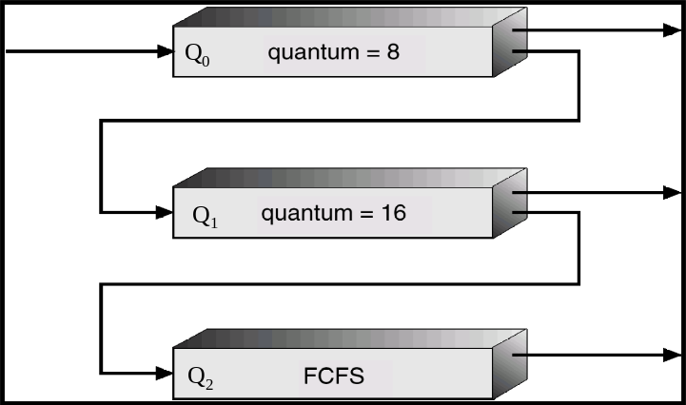
Given the following arrival time and CPU burst of processes A, B, C, D, and E as shown in table below.
Task | Arrival Time | Service Time
A | 0 | 25
B | 5 | 28
C | 19 | 11
D | 25 | 19
E | 36 | 33
a) Show the status of each queue along the time line during the running of the system. You only need to show the status of the system when either 1) a new process arrives, or 2) a process is preempted, or 3) a process terminates. The status includes time stamp, the name of the process and its remaining time in each queue. For example, at time 0, process A is in Q₀ and it has 25 time units toward finishing. Q₁ and Q₂ are empty. You are asked to complete the table with time moment and status of each queue. Moreover, B(x) A(y) shows A is at the head of the queue with x remaining time and B is at the tail of the queue with remaining time of y. You can add new rows to the table if you think the table is not enough to accommodate all the events.
Time | Q₀ | Q₁ | Q₂
0 | A(25) | --- | ---
5 | B(28)A(20) | --- | ---
8 | B(28) | A(17) | ---
16 | --- | B(20), A(17) | ---
19 | C(11) | B(20), A(14) | ---
25 | D(19), C(5) | B(20), A(14) | ---
27 | D(19) | C(3), B(20), A(14) | ---
35 | --- | D(11), C(3), B(20), A(14) | ---
36 | E(33) | D(11), C(3), B(20), A(13) | ---
44 | --- | E(25), D(11), C(3), B(20), A(13) | ---
56 | --- | E(25), D(11), C(3), B(20) | A(1)
72 | --- | E(25), D(11), C(3) | B(4), A(1)
75 | --- | E(25), D(11) | B(4), A(1)
86 | --- | E(25) | B(4), A(1)
102 | --- | --- | E(9), B(4), A(1)
103 | --- | --- | E(9), B(4)
107 | --- | --- | E(9)
116 | --- | --- | ---
--- | --- | --- | ---

